DIGITAL IMAGE PROCESSING

EC-312 DIGITAL IMAGE PROCESSING, Spring 19

Department of Computer and Software Engineering

2019

# LAB # 05: Transformation Operations

**Lab Objective:**

The objective of this lab is to enhance contrast of an image using contrast stretching and histogram equalization.

**Lab Description:**

***Contrast stretching:*** is a simple image enhancement technique that attempts to improve the contrast in an image by `stretching' the range of intensity values it contains to span a desired range of values. Normally (min, max) 🡪 (0, 255)

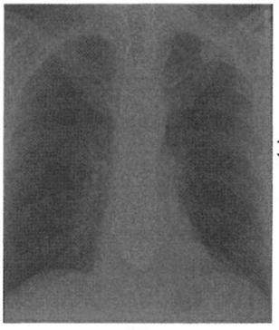

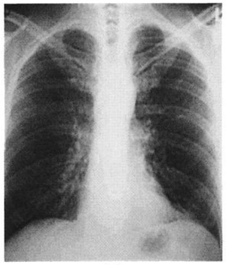

p = ((p-min)/ (max-min)) *255

Where:

p is pixel value at a certain pixel location

max, min is the max, min pixel value in the entire image

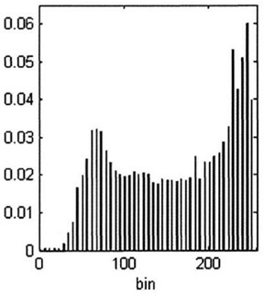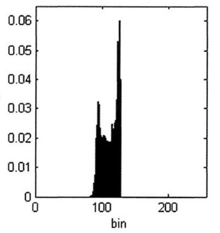

Instead of blindly computing the dynamic range using just the minimum and maximum pixel values, a more robust and adaptive technique is to use the **5th and 95th percentiles** of the input values when deriving the dynamic range of the input image.

***Histogram equalization:***

**Histogram** of an image shows the frequency of different intensities values present in the image. This gives a clear idea of what intensities dominate the image. **Histogram equalization** is a technique that uses this information to enhance the contrast using the probability of a certain pixel to occur.

**Steps:**

Suppose we have a 3-bit image (L = 8) of size 64x64

1. Calculate number of pixels per pixel value.

|  |  |  |  |  |  |  |  |  |
| --- | --- | --- | --- | --- | --- | --- | --- | --- |
| Pixel Value (rk) | 0 | 1 | 2 | 3 | 4 | 5 | 6 | 7 |
| No of Pixels (nk) | 790 | 1023 | 850 | 656 | 329 | 245 | 122 | 81 |

1. Calculate probability density function PDF = nk / size of the image

|  |  |  |  |  |  |  |  |  |
| --- | --- | --- | --- | --- | --- | --- | --- | --- |
| No of Pixels (nk) | 790 | 1023 | 850 | 656 | 329 | 245 | 122 | 81 |
| PDF | 0.19 | 0.25 | 0.21 | 0.16 | 0.08 | 0.06 | 0.03 | 0.02 |

1. Calculate cumulative density function CDF = sum of nk from 0 - k

|  |  |  |  |  |  |  |  |  |
| --- | --- | --- | --- | --- | --- | --- | --- | --- |
| PDF | 0.19 | 0.25 | 0.21 | 0.16 | 0.08 | 0.06 | 0.03 | 0.02 |
| CDF | 0.19 | 0.44 | 0.65 | 0.81 | 0.89 | 0.95 | 0.98 | 1 |

1. Calculate transformation function by multiplying CDF with (L – 1) and round of it.

|  |  |  |  |  |  |  |  |  |
| --- | --- | --- | --- | --- | --- | --- | --- | --- |
| CDF | 0.19 | 0.44 | 0.65 | 0.81 | 0.89 | 0.95 | 0.98 | 1 |
| TF | 1.33 | 3.08 | 4.55 | 5.67 | 6.23 | 6.65 | 6.86 | 7 |
| TF ( sk ) | 1 | 3 | 5 | 6 | 6 | 7 | 7 | 7 |

1. Replace original Pixel values with the sk values

|  |  |  |  |  |  |  |  |  |
| --- | --- | --- | --- | --- | --- | --- | --- | --- |
| Pixel Value ( rk ) | 0 | 1 | 2 | 3 | 4 | 5 | 6 | 7 |
| TF ( sk ) | 1 | 3 | 5 | 6 | 6 | 7 | 7 | 7 |

The Image obtained will be Histogram Equalized Image with high contrast.

## Some Useful Commands:

**Importing matplotlib:** import matplotlib.pyplot as plt

1. To calculate the mean of 2D array using NumPy: my_mean = **numpy. mean (my_array)**
2. To calculate min (or max) of an array: **my_min = numpy.amin(my_array)**
3. To calculate the power of an array using NumPy: array_power = **numpy.power (my_array, power)**
4. To obtain percentile value. **percentile_array = numpy.percentile(my_array, percentile)**
5. To change data type of array. **my_array = my_array. astype(numpy. uint16)**
6. To plot a simple plot using matplottlib: **plt.plot( my_data)**
7. For label along x axis: **plt.xlabel ( ‘Some cooked up data’)**
8. For label along y axis: **plt.ylabel ( ‘Some value’)**
9. To show the graph: **plt.show()**

## Lab Tasks:

**1:** Apply contrast stretching on the image of car provided by setting 5th and 95th percentiles of the input values to 0 and 255 respectively.

**2:** Now apply Histogram equalization on the same image.

1. Calculate the histogram of the image save it as Figure_1.jpg. (Don’t use any built-in function of OpenCV or NumPy etc.)
2. Calculate probability density function (PDF) from the histogram and save it as Figure_2.jpg. PDF = H/(R*C). Where H is the Histogram and R and C is the number of Rows and Columns of the image respectively.
3. Calculate cumulative density function (CDF) and save it as Figure_3.jpg.
4. Multiply the Cumulative PDF with 255 to find thetransformation function then save it as Figure_4.jpg
5. From the transformation function, replace the gray levels of the image to create contrast enhanced (histogram equalized) image and save it as Figure_5.jpg
6. Calculate the histogram of the output image save it as Figure_6.jpg.

**3:** After obtaining constrast streatched images from task 1 .Apply Power Law transformation for the following values of γ (0.2, 0.5, 1.2 and 1.8) . Make sure to adjust data types accordingly.

**Home Task:**

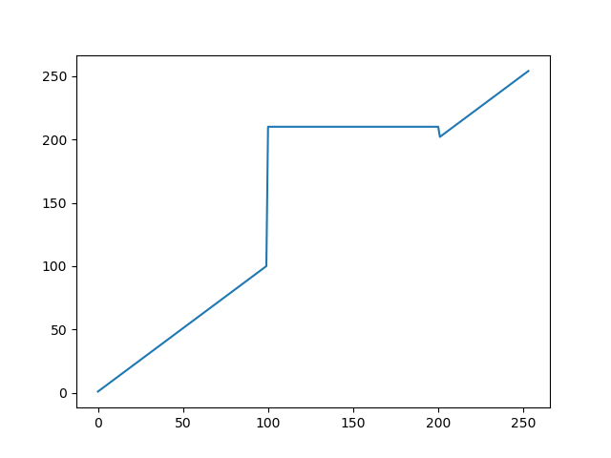**1:** After obtaining constrast streatched images from lab task 1 .Apply Gray level slicing using lower limit 100 and upper limit 200. Set all these values to 210.

**THINK!!**

1. How is histogram equalization different from contrast stretching?
2. In the image shown below almost 90% pixels have pixel value 220 and the rest 10% are greater than this value. Which process is better for contrast enhancement of this image, Histogram equalization or contrast stretching? Explain.

|  |  |  |  |  |  |  |
| --- | --- | --- | --- | --- | --- | --- |
| 220 | 220 | 235 | 220 | 240 | 220 | 220 |
| 220 | 220 | 220 | 230 | 220 | 255 | 220 |
| 220 | 220 | 220 | 220 | 250 | 220 | 245 |
| 220 | 220 | 220 | 220 | 220 | 220 | 220 |

1. If all the pixel values of an image are same, say 100 what will be the output of histogram equalization?
2. Is matplotlib using OpenCV for showing graphs?